Thank you for your interest in graduate training with the Sleep Lab at the University of Oregon! I receive so much email from potential applicants that I am not able to respond individually. There are also individual differences in who contacts me, so to reduce bias during application review, I try to keep email conversations brief and I don’t meet with potential applicants by phone, videoconference, or in person until I have completed the initial review of submitted applications. That said, I want to be as transparent as possible about what I will look for when reviewing applications. Here is some information that I have put together that should answer most questions. Additional information can be found on the websites for our lab (https://sleeplab.uoregon.edu), the Psychology Department (https://psychology.uoregon.edu), and the Center for Translational Neuroscience (https://ctn.uoregon.edu).
First, I DO plan to review applications from prospective graduate students this year. Applications submitted this fall are usually reviewed by December, department-wide interviews usually take place in January or early February, and notices of acceptance are typically sent in February through mid-April.
Second, prospective applicants should have interests that are closely aligned with the MoDA and MoRA projects that are described on the lab website. Your graduate research does not have to directly address the scientific aims of these projects, but you should be interested in using the data from these projects to develop your own research program. The MoDA and MoRA studies will be the major focus of the lab over the next five years. The scientific aims, participants, and measures for these projects are described on the next page to give you an idea of the breadth and depth of the data that will be available.
The MoDA and MoRA studies all use multimodal assessment of key constructs of interest, and a combination of observational and experimental study designs, so there are many questions that you could address. There may also be opportunities to add measures to the MoDA and MoRA studies, especially if the measures are brief and inexpensive.
Finally, you may want know what I look for in prospective applicants. First of all, make sure your application is complete. For example, your application may not be reviewed if you are missing letters of recommendation. You should also be sure to list me as a preferred mentor if you are applying to my lab.
Completed applications are rated by me and existing lab members along the following dimensions:
- Clarity of purpose in the applicant’s statement with clear connection to the training opportunities at UO
- Quality and extent of prior research, educational, and other training experiences with relevance to the applicant’s proposed research and training, including:
  - Research experience and skills, including but not limited to:
    - Publications, presentations, and awards
    - Writing and quantitative skills
    - Methodological skills (e.g., EEG, fMRI, HRV, clinical assessment, coding)
  - Experience, skill, and/or level of interest in working with clinical populations (if applicable)
  - Quality and relevance of coursework
  - Quality and relevance of employment and volunteer experiences (if applicable)
- Strength of letters of support
- Ability to work collaboratively and independently, prioritize responsibilities, and overcome obstacles
- Contribution of personal background and professional interests to diversity and equity in the Sleep Lab, Psychology Department, and fields of psychology and/or neuroscience
I review these ratings to make a decision about who I would like to invite to interview. I am usually able to invite 2-3 people to the departmental interview weekend for every graduate slot. I may conduct pre-interviews if I need more information prior to inviting applicants to the departmental interview weekend.
If you are invited to interview weekend, congratulations! This is a huge accomplishment! Interview weekend includes presentations about the UO training program, “meet and greets” and interviews with faculty and students, building/lab tours, and more! You should come away with a good sense of the training program and the social and environmental climate at UO. We will also talk more about your specific project ideas.
I wish you the best of luck with the application process. It is a lot of work, but it is also a good opportunity to reflect on your accomplishments and goals, learn about different training programs, and expand your professional network. I look forward to reviewing your application if you decide to apply to UO!

MoDA and MoRA Project Description
Aims
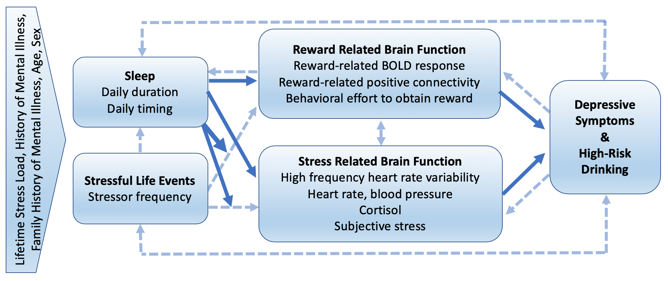
The scientific aims of these projects are to evaluate the extent to which sleep duration and timing during adolescence and young adulthood: 1) predict reward- and stress-related brain function, and moderate the effects of stressful life events; 2) impact reward- and stress-related brain function, and moderate the effects of stressful life events; and 3) thereby predict and impact symptoms of depression and alcohol use disorder (AUD; Figure 1).
Figure 1. Conceptual model in which sleep duration and timing contribute to subsequent depression and high-risk drinking by disrupting reward- and stress- related brain function. Solid lines represent relationships that are the primary focus of my research program. Dashed lines represent other effects of interest. Vertical text denotes additional risk factors for depression and alcohol use disorder that are considered in my research.
Participants
Participants in MoDA will include 150 adolescents (14-19 years of age) who are currently in high school. Recruitment will be stratified to include adolescents with short and late sleep (weekday sleep duration ≤ 6 h & midpoint ≥ 4 am; n=100) versus long and early sleep (weekday sleep duration ≥ 8h & midpoint ≤ 2:30 am; n=50). Participants will also be selected for enhanced lifetime exposure to stressful events and depressive symptoms. Participants in MoRA will include 150 young adults (18-24 years of age) who report past-month high-risk drinking (i.e., ≥ 4 drinks/day or ≥ 8/week for women, ≥ 5 drinks/day or ≥ 15/week for men) and high lifetime exposure to stressors. Recruitment will be stratified to include participants with short and late sleep (weekday sleep duration ≤ 6 h & midpoint ≥ 4 am; n=100) versus those with long and early sleep (weekday sleep duration ≥ 8h & midpoint ≤ 2:30 am; n=50)
Study Design
Figure 2 provides an overview of the study design for MoDA and MoRA. The observational arms of these projects will include daily ecologically-based assessments of sleep, stress, affect, and alcohol use for 2 weeks. The experimental arms of these studies will extend sleep duration and advance sleep timing by 90 minutes per night for 2 weeks in adolescents and young adults who typically have short and late sleep, and continue daily ecologically-based assessments of sleep, stress, affect, and alcohol use.
Measures
Major constructs of interest will be assessed using the measures in Tables 1 and 2. Sleep duration and timing will be assessed using behavioral and self-report measures. Reward-related brain function will be assessed using behavioral effort to obtain rewards as well as regional brain activity and functional connectivity measured by fMRI during monetary reward tasks. Stress-related brain function will be assessed using high-frequency heart-rate variability to index parasympathetic function, as well as additional measures of autonomic function (heart rate, blood pressure), endocrine function (cortisol), and subjective stress during a social stressor task. Symptoms of depression and AUD will be assessed using interviews, symptom questionnaires, and daily ecological measures.

Table 1. MoDA Study Measures and Schedule of Administration.
CONSTRUCT | MEASURE | SCHEDULE
 |  | Screening | Pre-intensive | 2-Week Intensive | Post-Intensive
Depression & Anhedonia | - Kiddie Schedule for Affective Disorders and Schizophrenia (K-SADS) | X
 | - PROMIS Depression scale | X | X |  | X
 | - PROMIS Positive affect scale  - Dimensional Anhedonia Rating Scale |  | X  X |  | X  X
 | - Daily positive affect and anhedonia items |  |  | X
Sleep and Circadian Rhythms | - Munich Chronotype Questionnaire | X
 | - Structured Clinical Interview for DSM-5 Sleep Disorders | X
 | - Actigraphy and daily Consensus Sleep Diary |  |  | X
 | - Slow wave activity during sleep polysomnography |  |  |  | X
 | - Dim light melatonin onset |  |  |  | X
Stressful Life Events | - Stress and Adversity Inventory (STRAIN) | X
 | - Daily Inventory of Stressful Events (DISE) |  |  | X
Reward-related Brain Function | - Reward Guessing Task during fMRI |  |  |  | X
 | - Effort Expenditure for Rewards Task (EEfRT) |  |  |  | X
 | - Behavioral Inhibition/Approach Scales (BIS/BAS) |  |  |  | X
Stress-related Brain Function | - Trier Social Stress Task with resting and stressor-related HRV, HR, BP, salivary cortisol, perceived stress |  |  |  | X
 | - Daily Perceived Stress Scale |  |  | X

Table 2. MoRA Study Measures and Schedule of Administration.
CONSTRUCT | MEASURE | SCHEDULE
 |  | Screening | Pre-intensive | 2-Week Intensive | Post-Intensive | Follow-up
Alcohol Use | - Alcohol Timeline Follow-Back (frequency, quantity) | X | X |  |  | X
 | - DIAMOND Substance Use Disorders Module | X
 | - Daily alcohol and drug use diary |  |  | X
Sleep and Circadian Rhythms | - Munich Chronotype Questionnaire | X
 | - Structured Clinical Interview for DSM-5 Sleep Disorders | X
 | - Actigraphy and Consensus Sleep Diary |  |  | X
 | - Slow wave activity during sleep polysomnography |  |  |  | X
 | - Dim light melatonin onset |  |  |  | X
Stressors | - Stress and Adversity Inventory (STRAIN) for young adults | X
 | - Daily Inventory of Stressful Events (DISE) |  |  | X
Reward-related Brain Function | - Monetary Incentive Delay (MID) task during fMRI |  |  |  | X
 | - Balloon Analogue Risk Task (BART) |  |  |  | X
 | - Behavioral Inhibition/Approach Scales (BIS/BAS) |  |  |  | X
 | - Alcohol and Drug Craving |  |  | X
Stress-related Brain Function | - Trier Social Stress Task with resting and stressor-related HR, BP, salivary cortisol, perceived stress |  |  |  | X
 | - Daily Perceived Stress Scale |  |  | X

